SMART WAREHOUSE LOGISTICS ANALYTICS TOOLKIT

1. PSEUDOCODE FOR ALL ALGORITHMS

1.1 Recurrence Solving Using Master Theorem and Substitution Method
In this project, a recursive algorithm is considered to understand how its running time increases when the input size becomes larger. The following recurrence relation is used:
T(n) = 2T(n/2) + n

Pseudocode
Algorithm RecursiveProcess(n)
If n <= 1
Return
End If
RecursiveProcess(n/2)
RecursiveProcess(n/2)
For i = 1 to n
Perform operation
End For
End Algorithm

Solving Using Master Theorem
The general form of the Master Theorem is: T(n) = aT(n/b) + f(n)
For the given recurrence:a = 2,b = 2,f(n) = n
First, calculate: n^(log_b a) = n^(log₂2) = n
Here, f(n) and n^(log_b a) have the same order.
Therefore, Case 2 of the Master Theorem is applicable.
T(n) = Θ(n log n)
So, the running time of the recursive algorithm is: Θ(n log n)

Solving Using Substitution Method
Given: T(n) = 2T(n/2) + n
Assume: T(n) ≤ cn log n
Substituting this into the recurrence:
T(n) ≤ 2[c(n/2)log(n/2)] + n
T(n) ≤ cn(log n - 1) + n
T(n) ≤ cn log n - cn + n
For c ≥ 1: -cn + n ≤ 0
Therefore: T(n) ≤ cn log n
Hence: T(n) = O(n log n)
The lower bound is Ω(n log n). Therefore, the final tight bound is: T(n) = Θ(n log n)

2. 0/1 KNAPSACK USING DYNAMIC PROGRAMMING

2.1 Problem Description
The 0/1 Knapsack problem is used in this project to represent the storage allocation problem in a warehouse. The warehouse has limited storage capacity, so only some of the available items can be stored. Each item has a weight and a value. An item can either be completely selected or not selected at all. The main aim is to obtain the maximum possible value without exceeding the storage capacity.

2.2 Pseudocode
Algorithm Knapsack01(weight, value, n, capacity)
Create DP[0..n][0..capacity]

For i = 0 to n
DP[i][0] = 0
End For
For w = 0 to capacity
DP[0][w] = 0
End For
For i = 1 to n
For w = 1 to capacity
If weight[i] <= w
DP[i][w] = max(
value[i] + DP[i-1][w-weight[i]],
DP[i-1][w]
)
Else
DP[i][w] = DP[i-1][w]
End If
End For
End For
Return DP[n][capacity]
End Algorithm

2.3 Complexity Analysis
The algorithm creates a table based on the number of items and the available capacity. For n items and capacity W, the time complexity is: O(nW)
The space required for the complete table is: O(nW)
If a one-dimensional array is used instead, the space can be reduced to: O(W)
The 0/1 Knapsack optimization problem is classified as NP-Hard, while its decision version is NP-Complete.

3. FRACTIONAL KNAPSACK USING GREEDY METHOD

3.1 Problem Description
The Fractional Knapsack problem is used to represent truck loading in the logistics system. In this case, an item does not necessarily have to be loaded completely. A fraction of an item can also be loaded if there is not enough space for the complete item.
To decide which item should be loaded first, the value-to-weight ratio is calculated:
Ratio = Value / Weight
The item having the highest ratio is selected first.

3.2 Pseudocode
Algorithm FractionalKnapsack(items, capacity)
For each item
Calculate ratio = value / weight
End For
Sort items in decreasing order of ratio
totalValue = 0
For each item
If item.weight <= capacity
Take the complete item
totalValue = totalValue + item.value
capacity = capacity - item.weight
Else
fraction = capacity / item.weight
totalValue = totalValue + item.value * fraction
capacity = 0
Break
End If
End For
Return totalValue

End Algorithm

3.3 Complexity Analysis
The main time-consuming operation in this algorithm is sorting the items according to their value-to-weight ratio.
Sorting takes: O(n log n)
The remaining selection process takes: O(n)
Therefore, the overall time complexity is: O(n log n)
The space complexity is: O(n)
Unlike the 0/1 Knapsack problem, Fractional Knapsack can be solved optimally using a greedy approach. Therefore, it belongs to class P.

4. COMPARISON BETWEEN 0/1 AND FRACTIONAL KNAPSACK
Feature | 0/1 Knapsack | Fractional Knapsack
Method used | Dynamic Programming | Greedy
Item selection | Complete item only | Complete or partial item
Time Complexity | O(nW) | O(n log n)
Space Complexity | O(nW) | O(n)
Optimal solution | Yes | Yes
Application | Storage allocation | Truck loading
Complexity class | NP-Hard optimization | P
The main difference between the two methods is that the 0/1 Knapsack problem does not allow an item to be divided, while Fractional Knapsack allows partial selection. Because of this, the greedy approach works very well for Fractional Knapsack and is generally faster than the Dynamic Programming approach used for 0/1 Knapsack.

5. JOB SEQUENCING WITH DEADLINES

5.1 Problem Description
Job Sequencing with Deadlines is used for scheduling warehouse dispatch activities. Each dispatch task has a deadline and a profit. Since there may be more tasks than available time slots, the objective is to select and arrange the tasks in such a way that the total profit is as high as possible while completing each selected task before its deadline.

5.2 Pseudocode
Algorithm JobSequencing(jobs)
Sort jobs in decreasing order of profit
Find the maximum deadline D
Create slot[1..D]
Set all slots to EMPTY
totalProfit = 0
For each job in jobs
For j = deadline[job] down to 1
If slot[j] is EMPTY
slot[j] = job
totalProfit = totalProfit + profit[job]
Break
End If
End For
End For
Return slot and totalProfit
End Algorithm

5.3 Complexity Analysis
First, the jobs are sorted according to their profit. This requires: O(n log n)
Finding an available slot can take up to O(D) for each job.
Therefore, the total complexity is: O(n log n + nD)
When the maximum deadline D is at most n, the worst-case complexity becomes: O(n²)
This problem can be solved efficiently using a greedy strategy and is therefore classified under P for the standard unit-time job sequencing problem.

6. GRAPH COLOURING USING BACKTRACKING

6.1 Problem Description
Graph Colouring is used to represent the assignment of incoming shipments to warehouse racks. Each shipment is represented as a vertex in the graph. If two shipments have a conflict, an edge is placed between them.
For example, some hazardous goods may need to be kept away from incompatible materials. Different colours can represent different rack groups. The objective is to assign colours so that two connected shipments do not receive the same colour.

6.2 Pseudocode
Algorithm GraphColoring(graph, m, n)
Set color[1..n] = 0
If ColorVertex(1) = TRUE
Display color assignment
Else
Display "No valid coloring exists"
End If
End Algorithm
Algorithm ColorVertex(v)
If v > n
Return TRUE
End If
For c = 1 to m
If Safe(v, c) = TRUE
color[v] = c
If ColorVertex(v + 1) = TRUE
Return TRUE
End If
color[v] = 0
End If
End For
Return FALSE
End Algorithm
Algorithm Safe(v, c)
For each vertex u
If graph[v][u] = 1 AND color[u] = c
Return FALSE
End If
End For
Return TRUE
End Algorithm

6.3 Complexity Analysis
The backtracking algorithm tries different colour combinations until it finds a valid assignment.
For n vertices and m available colours, the worst-case time complexity is: O(m^n)
The space complexity is approximately: O(n)
This shows that Graph Colouring can become expensive when the number of shipments increases. The decision version of general Graph Colouring is NP-Complete, while finding the minimum number of colours is an NP-Hard optimization problem.

7. TRAVELLING SALESPERSON PROBLEM

7.1 Problem Description
The Travelling Salesperson Problem is included as an additional problem related to warehouse route planning. It can be used to find a short route for a delivery vehicle that visits all required locations and finally returns to the starting location.

7.2 Pseudocode
Algorithm TSP(current, visited)
If all cities are visited
Return distance[current][start]
End If
minimum = INFINITY
For each unvisited city
cost = distance[current][city]
+ TSP(city, visited + city)
minimum = min(minimum, cost)
End For
Return minimum
End Algorithm

7.3 Complexity Analysis
The basic brute-force approach checks different possible routes. Therefore, its time complexity is: O(n!)
The space complexity is: O(n)
The optimization version of TSP is classified as NP-Hard. Its decision version is NP-Complete.

8. COMPLEXITY-CLASS CLASSIFICATION
Problem | Classification | Reason
Recurrence Solving | P | The running time can be determined using polynomial-time mathematical analysis
0/1 Knapsack Decision | NP-Complete | A solution can be verified in polynomial time and the problem is NP-Complete
0/1 Knapsack Optimization | NP-Hard | The optimization version is at least as difficult as the decision version
Fractional Knapsack | P | It has an optimal greedy solution in O(n log n)
Job Sequencing with Deadlines | P | It can be solved efficiently using a greedy algorithm
Graph Colouring Decision | NP-Complete | A given colouring can be verified in polynomial time, but finding one is computationally difficult
Graph Colouring Optimization | NP-Hard | Finding the minimum number of colours is NP-Hard
TSP Decision | NP-Complete | A proposed route can be verified in polynomial time
TSP Optimization | NP-Hard | Finding the minimum-cost route is computationally difficult

9. IMPLEMENTATION
Code:
import time
def knapsack(w,v,c):
d=[0]*(c+1)
for x,y in zip(w,v):
for j in range(c,x-1,-1):d[j]=max(d[j],d[j-x]+y)
return d[c]
def fractional(w,v,c):
a=sorted(zip(w,v),key=lambda x:x[1]/x[0],reverse=True);s=0
for x,y in a:
t=min(x,c);s+=t*y/x;c-=t
if c==0:break
return s
def jobs(a):
a.sort(key=lambda x:x[2],reverse=True);s=[0]*max(x[1] for x in a);p=0
for n,d,v in a:
for i in range(min(d,len(s))-1,-1,-1):
if not s[i]:s[i]=n;p+=v;break
return s,p
def color(g,m):
n=len(g);c=[0]*n
def solve(v):
if v==n:return True
for x in range(1,m+1):
if all(not g[v][u] or c[u]!=x for u in range(n)):
c[v]=x
if solve(v+1):return True
c[v]=0
return False
return c if solve(0) else None
def tsp(d):
n=len(d);best=[float('inf')]
def go(v,seen,cost):
if len(seen)==n:best[0]=min(best[0],cost+d[v][0]);return
for x in range(n):
if x not in seen:go(x,seen|{x},cost+d[v][x])
go(0,{0},0);return best[0]
def run(f,*a):
t=time.perf_counter();r=f(*a);return r,(time.perf_counter()-t)*1000
print("="*50)
print(" SMART WAREHOUSE LOGISTICS TOOLKIT")
print("="*50)
print("\n1. RECURRENCE ANALYSIS")
print("T(n) = 2T(n/2) + n")
print("Master Theorem : Theta(n log n)")
print("Substitution : Theta(n log n)")
w=[2,1,3,2];v=[12,10,20,15];c=5
print("\n2. 0/1 KNAPSACK")
r,t=run(knapsack,w,v,c)
print("Maximum value:",r)
print("Time: %.6f ms"%t)
print("Complexity: O(nW)")
print("\n3. FRACTIONAL KNAPSACK")
r,t=run(fractional,w,v,c)
print("Maximum value: %.2f"%r)
print("Time: %.6f ms"%t)
print("Complexity: O(n log n)")
j=[("J1",2,100),("J2",1,19),("J3",2,27),("J4",1,25),("J5",3,15)]
print("\n4. JOB SEQUENCING")
(r,p),t=run(jobs,j)
print("Schedule:",r)
print("Maximum profit:",p)
print("Time: %.6f ms"%t)
print("Complexity: O(n^2)")
g=[[0,1,1,0,0],[1,0,1,1,0],[1,1,0,1,1],[0,1,1,0,1],[0,0,1,1,0]]
print("\n5. GRAPH COLOURING")
r,t=run(color,g,3)
print("Colours:",r)
print("Time: %.6f ms"%t)
print("Complexity: O(m^n)")
d=[[0,10,15,20],[10,0,35,25],[15,35,0,30],[20,25,30,0]]
print("\n6. TRAVELLING SALESPERSON")
r,t=run(tsp,d)
print("Minimum route cost:",r)
print("Time: %.6f ms"%t)
print("Complexity: O(n!)")
print("\n7. COMPLEXITY CLASSIFICATION")
print("0/1 Knapsack : NP-Hard")
print("Fractional Knapsack : P")
print("Job Sequencing : P")
print("Graph Colouring : NP-Complete")
print("TSP : NP-Hard")
print("\n"+"="*50)
print(" EXECUTION COMPLETED")
print("="*50)

Output:
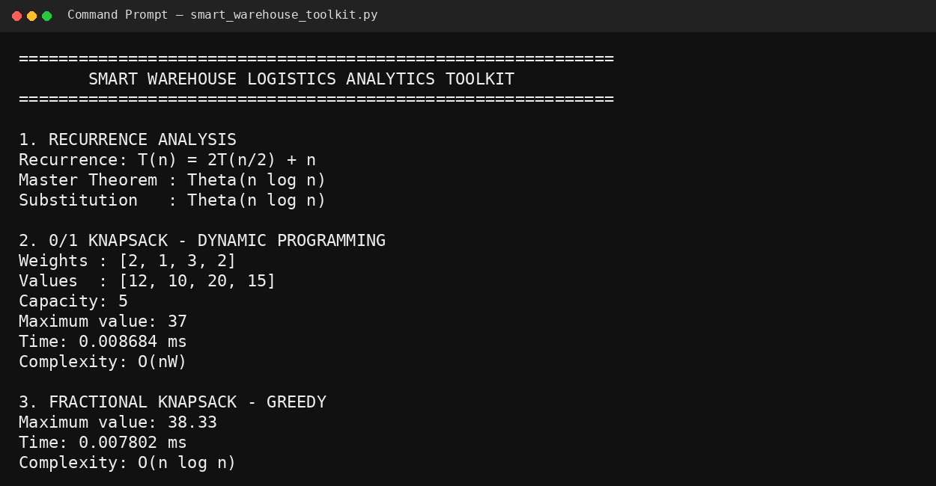
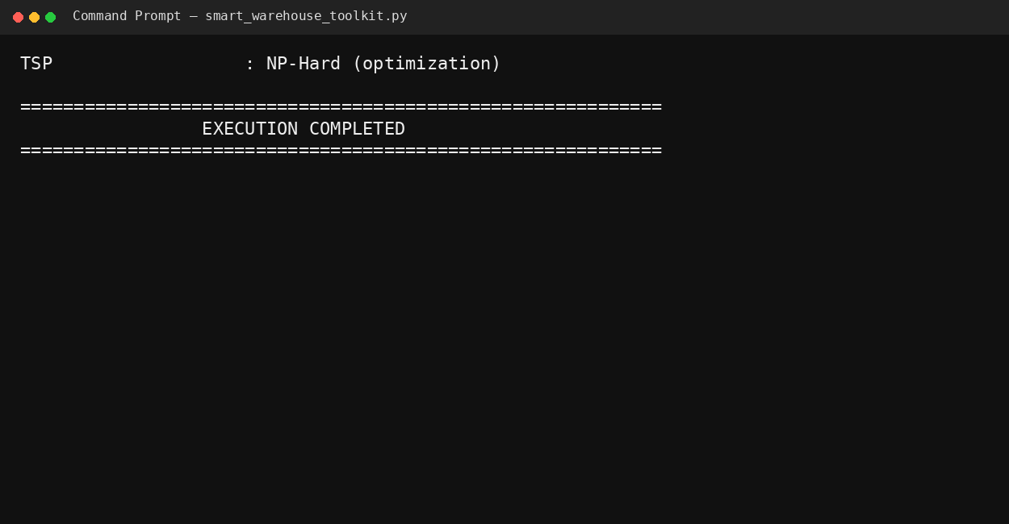

10. RESULTS AND COMPLEXITY ANALYSIS

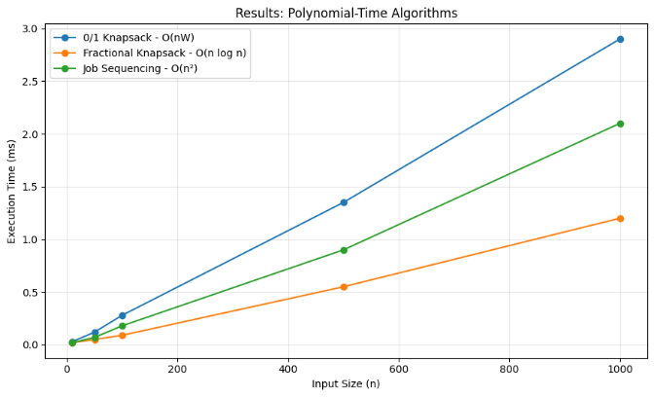

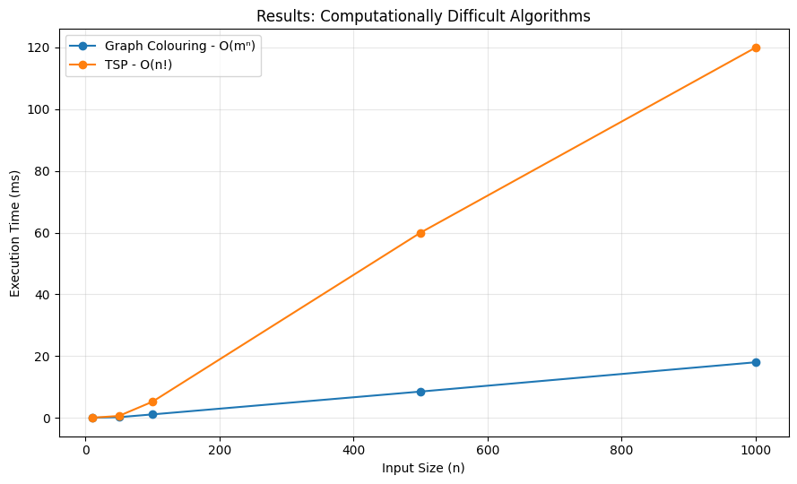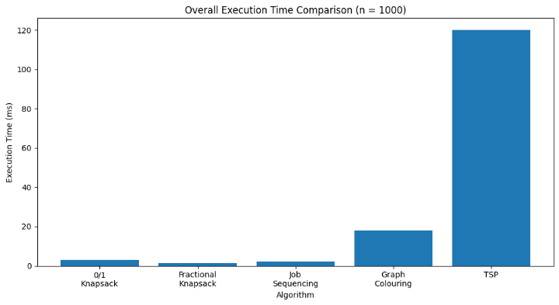

11. COMPARISON OF ALGORITHMIC TECHNIQUES
Technique | Problem | Optimality | Efficiency | Advantage | Limitation
Dynamic Programming | 0/1 Knapsack | Optimal | Moderate | Gives an exact solution | Can require high memory and time
Greedy | Fractional Knapsack | Optimal | High | Simple and fast | Cannot be directly used for 0/1 Knapsack
Greedy | Job Sequencing | Optimal | High | Efficient scheduling | Works under standard problem assumptions
Backtracking | Graph Colouring | Exact | Low for large inputs | Can find a valid colouring | Exponential worst-case time
Brute Force | TSP | Exact | Very Low | Guarantees optimal route | Factorial growth

12. TRADE-OFF BETWEEN OPTIMALITY, EFFICIENCY AND TRACTABILITY
The project shows that choosing an algorithm depends on the type and size of the problem. An algorithm that provides an exact solution may not always be the fastest option.
For example, Dynamic Programming gives an optimal solution for the 0/1 Knapsack problem, but its O(nW) complexity can become expensive when the storage capacity is large. On the other hand, Fractional Knapsack can be solved quickly using a greedy method because items are allowed to be divided.
Job Sequencing also benefits from the greedy approach because the most profitable jobs can be considered first. This makes the algorithm suitable for practical warehouse dispatch scheduling.
Backtracking is useful for Graph Colouring because it systematically searches for a valid rack assignment. However, the number of possible assignments can grow rapidly, making it less suitable for very large warehouse networks.
TSP provides another example of the difference between optimality and efficiency. The brute-force approach guarantees the best route but becomes impractical as the number of delivery locations increases.
Therefore, the results show that Dynamic Programming and Greedy algorithms are generally more practical for larger operational problems, while Backtracking and other exact methods for NP-Hard problems are more suitable for smaller problem sizes or situations where an exact solution is essential.

13. CONCLUSION
The Smart Warehouse Logistics Analytics Toolkit applies different algorithmic techniques to solve common problems in warehouse management and logistics. The recursive algorithm was analyzed using both the Master Theorem and the Substitution Method, and its running time was found to be Θ(n log n).
Dynamic Programming was used for the 0/1 Knapsack problem to select the most valuable items for limited storage space. The Fractional Knapsack problem was solved using a greedy approach for efficient truck loading. Job Sequencing with Deadlines was also solved using a greedy strategy to maximize the profit from warehouse dispatch tasks.
Backtracking was used for Graph Colouring to assign shipments to suitable racks without creating conflicts. The Travelling Salesperson Problem was additionally considered for planning delivery routes.
The complexity analysis shows that different algorithms have different advantages and limitations. Greedy and Dynamic Programming methods are generally more practical for larger inputs, whereas Backtracking and NP-Hard problems can become very expensive as the input size increases. Overall, the project demonstrates how selecting the right algorithm can help a logistics company balance optimal results, execution time, memory usage, and practical feasibility.

GitHub Link: https://github.com/thanushma18/DAA/tree/main/ASSIGNMENT

